WANTED PERSONS – LOCAL ONLY
Lancaster County Sheriff’s Office 8293 Mary Ball Road, Lancaster, VA
Effective March 25, 2026
 | Ball, Jonasia Monique 22 years old 5’ 03” 200 lbs.  227 Sadler Drive, Newport News, VA  19 Brent Court, Lancaster, VA  1131 Bluff Point Road, Kilmarnock, VA  Felony Probation Violation on 02/26/2026
 | Ball, Malik Raquel 25 years old 5’ 07” 146 lbs.  651 E. Eighth Street, Charlotte, NC  11022 River Road, Lancaster, VA  Non-Support of $7993.93 as of 10/22/2025
 | Baublitz, Clayton Nathaniel 40 years old 5’ 00” 200 lbs.  103 Morattico Road, Lancaster, VA  Failure to Appear on 10/10/2018 (Peeping into Dwelling)
 | Dade, Kyre Lamar 35 years old 5’ 11” 185 lbs.  3177 Lara Road, Lancaster, VA  Failure to Appear on 12/22/2025 (Child Support -Gloucester County case)
 | Drake, Terrance Dowayne Jr. 26 years old 5’ 04” 165 lbs.  96 Turner Lane, White Stone, VA  Possess Firearm while Violating Protective Order on 05/01/2025
 | Fontaine, William Madison 72 years old 6’ 00” 230 lbs.  1394 Hunton Lane, Lancaster, VA  Reckless Handling of a Firearm on 06/05/2024
 | Garcia, Kiwana Yiesha 54 years old 5’ 07” 220 lbs  2911 Browns Store Road, Heathsville, VA  458 Newmans Neck Road. Heathsville, VA  Failure to Appear on 07/21/2021 (Bad Checks)
 | George, John Robert 36 years old 5’ 00” 170 lbs.  84 Third Avenue, Kilmarnock, VA  113 Sandlin Drive, White Stone, VA  Felony Probation Violation on 10/08/2013 (Possess Controlled Substance)
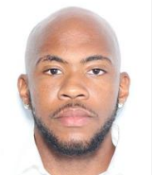 | Gregory, Donovan Ramon 26 years old 5’ 07” 175 lbs.  678 Newtown Road, White Stone, VA  Felony Probation Violation on 02/20/2026
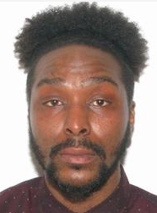 | Haskins, Lintez Jentel 38 years old 6’ 03” 175 lbs.  2032 Jessie Dupont Memorial Highway, Burgess, VA  3540 Merry Point Road, Lancaster, VA  Wanted for Failure to Appear on 10/28/2025 (original case Child Support)
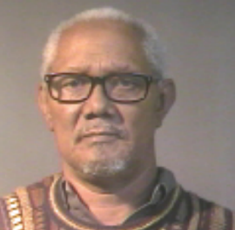 | Jones, Harry Lee 71 years old 5’ 09” 190 lbs.  2909 Norfolk Avenue, Baltimore, MD  12988 River Road, Lancaster, VA  Failure to Appear on 02/01/2017 (Damage Property – Under Advisement)
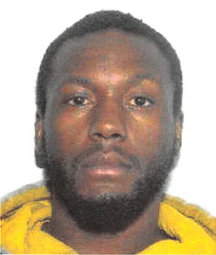 | Keyser, Brandon Randolph 33 years old 5’ 08” 180 lbs.  844 Regent Road, Topping, VA  Motor Vehicle Theft on 04/07/2024  see also Dorsey-Brown, Mahogany Yvonne Laquay
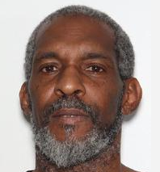 | Liciaga, Julio 57 years old 5’ 07” 165 lbs.  900 E. Princess Anne Road Apt 104,Norfolk, VA  1401 Fleeton Road, Reedville, VA  Failure to Appear on 12/03/2025 (Shoplifting)
 | Ludwig, James David 44 years old 5’ 11” 190 lbs.  283 Weems Road, Weems, VA  Felony Probation Violation on 02/07/2024
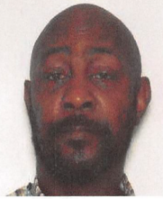 | Martin, Kenneth Brown Jr. 53 years old 6’ 01” 200 lbs.  151 Turner Lane, White Stone, VA  430 Logan Place Apt. 31, Newport News, VA  106 Suite Life Circle Apt. L1, Newport News, VA  Failure to Appear on 04/16/2025 (Fail to Comply with VASAP)
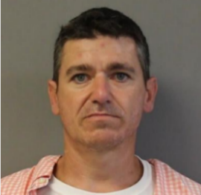 | McGurren, Allen Blair 41 years old 5’ 08” 155 lbs.  484 Hull Harbor Road, Heathsville, VA  4579 Cook Road, Marianna, FL  Failure to Appear on 10/22/2025 (Reckless Driving)
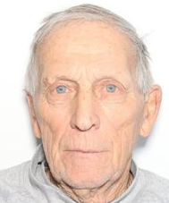 | Olsen, Kent Elnar 82 years old 5’ 06” 143 lbs  497 Whittaker Lane, Kilmarnock, VA  40 Windjammer Lane White Stone, VA  Fail to Appear on 03/12/2026 Show Cause Summons Essex County Case
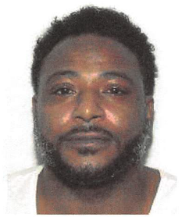 | Rich, LaTrayven Dewoyne 43 years old 5’ 07” 185 lbs  201 Folly Neck Road, Warsaw, VA  12988 River Road, Lancaster, VA  Non-Support of $9,431.09 as of 08/31/2024 Civil Capias
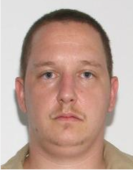 | Rosner, Matthew Quentin 40 years old 5’ 08” 150 lbs.  210 Oak Hill Road, Lancaster, VA  384 Eskimo Hill Road, Stafford, VA  Felony Probation Violation on 11/04/2015 (Shoplifting)
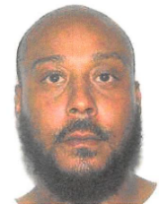 | Saul, Clifton O’Neal Sr. 42 years old 5’ 09” 215 lbs.  687 Chestnut Grove Lane, Heathsville, VA  Felony Probation Violation on 07/09/2024 (Drug Distribution)
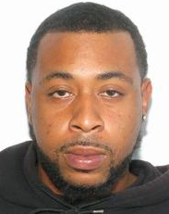 | Saunders, Jerrick Deion 33 years old 6’ 03” 220 lbs  203 Rocky Neck Road, Lancaster, VA  4 Count Felony Bond Violation, 1 Count Trespass on 04/24/2025
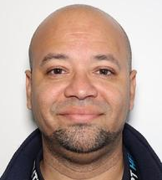 | Schaffer, James David III 44 years old 5’ 11: 175 lbs.  255 Kathy Drive, Lancaster, VA  VASAP Violation on 02/07/2024 (DUI)
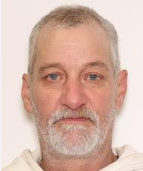 | Senter, Jeffery James 56 years old 5’ 11” 165 lbs.  411 Mount Zion Road, Church View, VA  Wanted for Failure to Appear on 12/01/2025 (underlying charge Drive Suspended)
 | Smith, Daishuane Jermiaha 23 years old 6’ 01” 161 lbs  413 Buzzards Neck Road, Lancaster, VA  Wanted for Bond Violation on 03/202/2026 Westmorelan Show Cause Summons
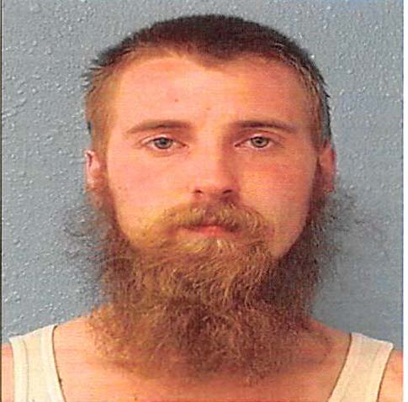 | Snyder, Jayson Calib 31 years old 5’ 07” 175 lbs.  1932 River Road, Lancaster, VA  110 Hidden Valley Ranch Road, Ilfield, NM  Failure to Appear on 06/13/2023 (Domestic Assault, Failure to Appear on 05/23/2023; Pretrial Services Violation on 06/29/2023)
 | Stewart, Brittany Monique 31 years old 5’ 00” 150 lbs.  691 Apple Grove Road, Kilmarnock, VA  835 35th Street, Newport News, VA  Fail to Appear on 12/13/2024 (case review: Destruction of Property and DUI)
 | Walters, Kionte Richon 35 years old 6’ 00” 180 lbs  528 Pine Point Drive, Heathsville, VA  216 Wishing Well Lane, Lancaster, VA  440 E. Church Street, Kilmarnock, VA  4 Counts Felony Probation Violation on 03/02/2026
 | Washington, Antonio Owens 30 years old 5’ 04” 120 lbs.  1435 Chestnut Grove Road Lancaster, VA  Failure to Appear on11/12/2014 (original charge Trespass)
 | Williams, Latrelle Jovan 33 years old 5’ 07” 140 lbs.  2340 Devils Three Jump Road, Little Plymouth, VA  Annoying Telephone Calls on 11/07-09/2017

